

**Effect of Design Patterns on Maintainability**

**By**

**Uday Akiti**

**Professor**

**Fadi Wedyan**

Submitted in partial fulfillment of the requirements

of

Object Oriented Development

**Date:01-07-2022**

# ACKNOWLEDGMENTS

On this occasion I would like to thank our professor Mr.Fadi Wedyan who guided us through out the semester. He extended his knowledge in the form of videos and slides. OOD being the tough subject, we learnt great concepts through the reference materials. The concepts I like the most are GQM, Different design patterns, characteristics of design patterns.

Finally, I also want to extend my gratitude to my friends who cleared my doubts whenever I questioned them.

1. **ABSTRACT**

In this research paper, I want to perform an empirical evaluation to measure the effect of Design patterns on maintainability. Here I am using ‘Design pattern’ as my ‘independent variable’ and the quality variable I want to monitor is ‘maintainability’. In the paper I will try to use almost all the design patterns for experimenting. As already mentioned, these types of studies play a major role in software engineering.

1. **INTRODUCTION**

I am trying to study the impact of all the design patterns on the software maintainability. For this I will download a large project implementing all the design patterns from git containing more than 1K lines of code.

The link is: <https://github.com/Michael-Stroh/Design-Patterns-Project>

In the project I will be developing and studying different ck metrics using a tool which calculates class-level and method-level code metrics.

And I also use a design pattern detection tool further.

1. **BACKGROUND**

Researchers say that Design patterns were created to increase software quality and speed up software development. They explain answers to common design difficulties. The selection of an ideal design that is suited to a specific application and problem does provide some challenges, though. Therefore, the findings about the impact of design patterns on the quality of software are debatable at this time.

Even I want to perform some case study, experiment and retrieve my own results.

1. **METHODOLOGY**

I would like to say that the methodology I used in the project are observation, case study and experiment. My project is using ‘Design Pattern detection using Similarity Scoring’. The specific tool uses I’ root of the project package’ as input and we need to select the type of the design pattern. As already mentioned, I want to study about all the design pattern, so I am choosing ‘all’. It is a mandatory for the project to contain the class files. The result can be viewed in the tool itself or can be exported and stored in the form of XML.

The below is the example of command performed in command prompt for generating ck metrics.

‘java -jar ck-0.7.1-SNAPSHOT-jar-with-dependencies.jar C:\projects\java_design_patterns-master false 0 true c:\temp\’

Studying at least three ck metrics.

1. **RESULTS**

The project I used is ‘java_design_patterns-master’

The ck metrics obtained are:

**CK metrics:**



Among all the csv files generated, I will be monitoring class.csv

Now, detecting the design patterns used in the project:

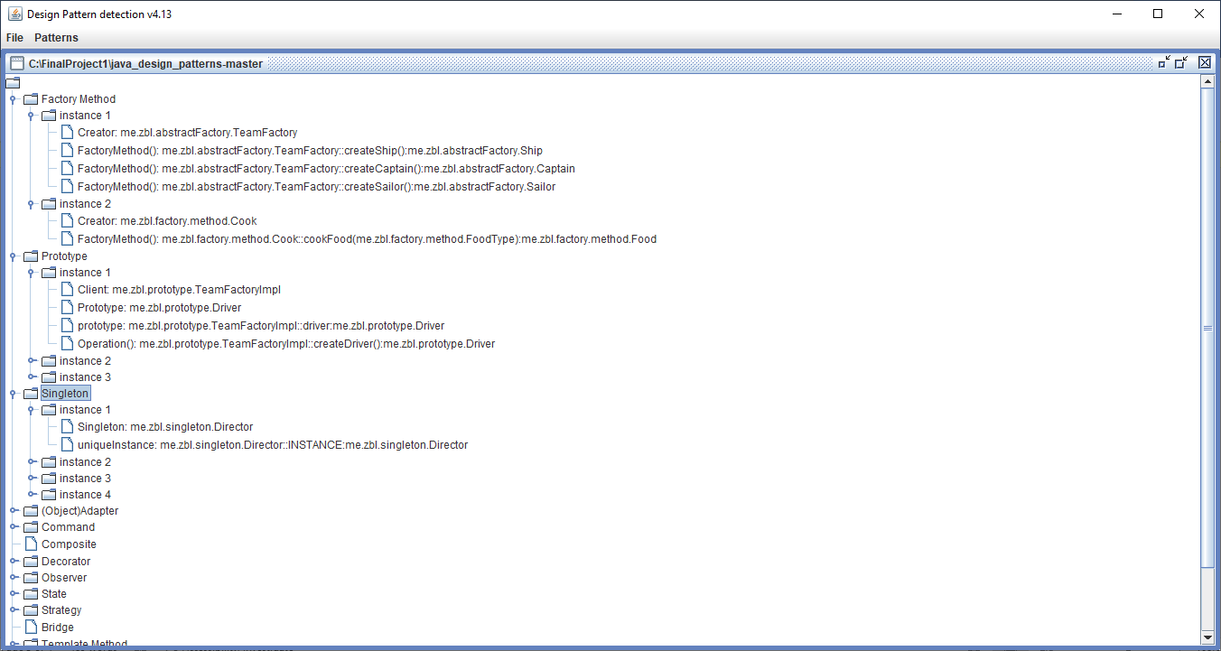

I am also exporting the output to XML file attached below:



The xml shows the classes using different design patterns.

Actually, the tool detects around 15 patterns, but my project used only 12 patterns as you can observe in the result xml.

1. **OBSERVATION**

Now, I will map the classes using design patterns to class.csv and analyses the metrics. LCOM, RFC, DIT are taken into consideration. It is difficult for me to analyze all the classes, so I will go ahead with few of them.

Randomly I have picked one class per each design pattern and viewed the LCOM, RFC, DIT values by highlighting them.

As per the rule:

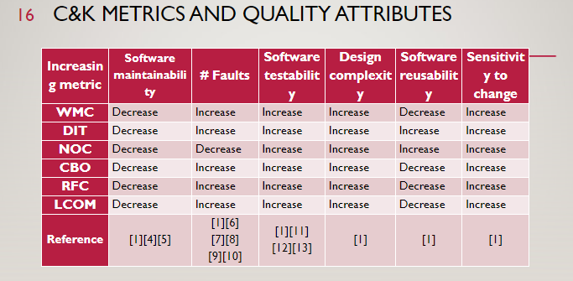

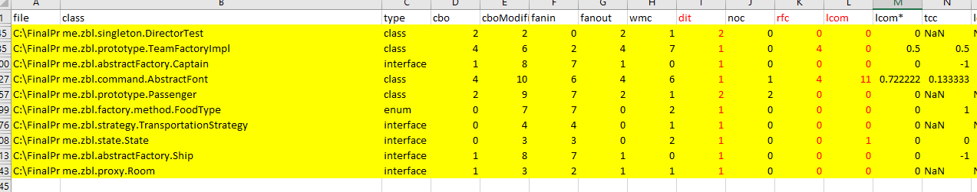

Low dit, rfc, lcom values lead to **high software maintainability**.

1. **CONCLUSION**

So, I want to conclude that using different design patterns aids to good software maintainability from the observation and experiment I did.

1. **REFERENCES**
2. <https://github.com/mauricioaniche/ck>
3. <https://github.com/Michael-Stroh/Design-Patterns-Project>
4. [**https://users.encs.concordia.ca/~nikolaos/pattern_detection.html**](https://users.encs.concordia.ca/~nikolaos/pattern_detection.html)
5. Impact of design patterns on software quality:a systematic literature review, by Fadi Wedyan, Somia Abufakher